**911 Call Data Analysis**

**Group-14**

Akshay Pandey

Manish Sharma Addanki

Nishi Ajay Mandhana

Sai Sri Krishna Karuturi

*Abstract* — This project is about analyzing emergency 911 call records for Montgomery County, PA. and producing meaningful visualizations and results using Python and SQLite.

# **Introduction**

In today’s world, with rapid increase in population there is a great need to constantly improve the efficiency of public emergency services and data analysis plays a key role in it. One such emergency service is 911, which is a hotline number that connects you to emergency service dispatchers. The first known use of a national emergency telephone number began in the United Kingdom in 1937–1938 using the number 999. It was later adopted by the United States in 1968 with the number 911 which was chosen by AT&T — which at the time operated nearly all telephone connections in the U.S. They have chosen this number as it was short, easy to remember, and unique as 911 had never been used as an area code or service code before. When you place a 911 call, your cell phone provider or phone company will route it to a public safety answering point (PSAT) or 911 call center nearest to your location. In Our project we are looking into Emergency (911) Calls of incidents of Fire, Traffic, EMS for Montgomery County.

# **Data Set and model**

The dataset for this analysis is taken from Kaggle and it contains records of 911 calls of Montgomery County Pennsylvania from Dec-2015 to July-2020 June.The entire county consisted of 68 townships and all the emergency incidents are categorized into 3 types namely Fire, EMS and Traffic. The file format is ‘.csv’ and has 663522 records with 9 fields.

# **Normalized Database Schema**

The dataset has been normalized into 5 five databse tables and SQLite (which is a relational database management system) has been chosen as the databse system for the project. Of five tables created – there is one main table called ‘CallRecord’ and four master data tables namely IncidentCategory, IncidentSubCategory,Township, TimeofDay. Below is the database schema.

# **Analysis and Results**

I. In the dataset we had data of total 68 townships in Montgomery County, of them just 11 townships have accounted for almost 50% of the call traffic, among these Lower Merion, Abington and Norristown are the top 3 townships in terms of call traffic from 2015 to 2020. Below is the tabular representation of the top 11 townships.

II. We have tried to visualize call traffic during each time of the day i.e., Morning (5 A.M – 12 P.M), Afternoon (12 P.M – 5 P.M), Evening (5 P.M – 9 P.M), Night (9 P.M – 5 A.M(next day)). In the below pie chart, we can see that most of the calls are received during mornings and afternoon where 30% of call traffic is during morning and 31% during afternoon.

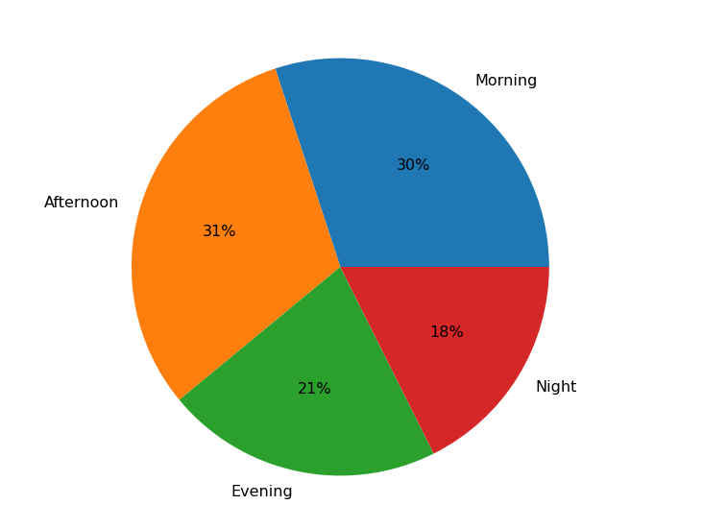

III. In our data we have incidents belonging to 3 categories namely EMS, Fire and Traffic. We have analyzed the trend in the number of incidents for each category over the years 2016 to 2020 June and the trend of overall incidents during the same time period. The data for 2020 is just for 7 months.

# **Applications and Future Research Directions**

The analysis performed in our project can help prepare for better emergency response as our analysis highlighted the most frequent subcategories of emergencies, the time-based web maps that helped locate some of the Hotspots where most resources can be deployed in preventing / handling the emergencies.

Depending on the above analysis, we further need to study the factors that made certain counties record a greater number of emergency incidents than others. As we have observed that number of incidents over the years hasn’t been declining, we need to research on what new guidelines/improvements in the system might help reduce the incidents.

# **References**

Dataset –

<https://www.kaggle.com/mchirico/montcoalert>

911 historical information –

<https://en.wikipedia.org/wiki/9-1-1>

Maps visualization - <https://pythonvisualization.github.io/folium/plugins.html>

# **Appendix**

**EMS** – Emergency Medical Services